- On the home page of your MyBethel account, click on the Make a Payment link:
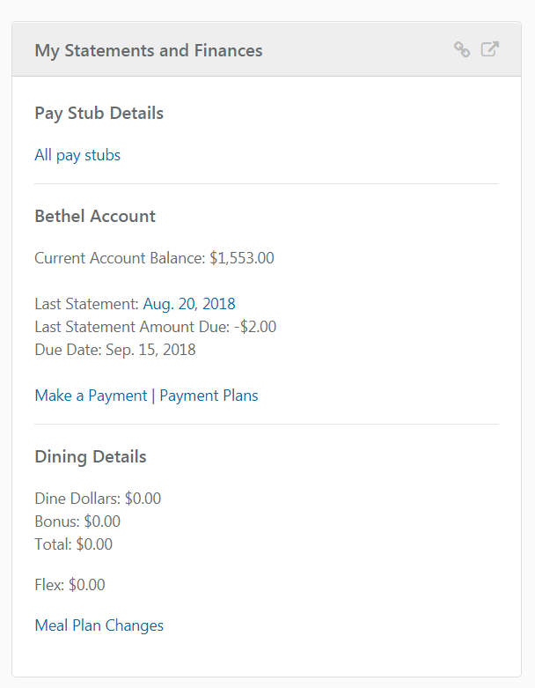

- On the Payment Portal home page, click the Make Payment button:
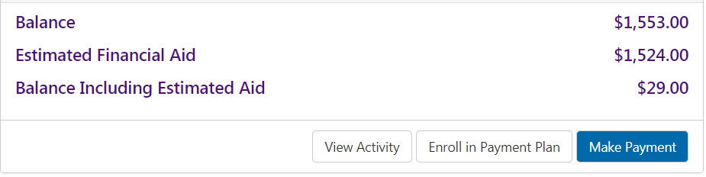
- On the Account Payment page select the amount due button (you may type into the box the amount you would like to pay if electing not to pay the amount due)
- Bank Wire payments cannot be scheduled for a future date, the date selected must be the current date.
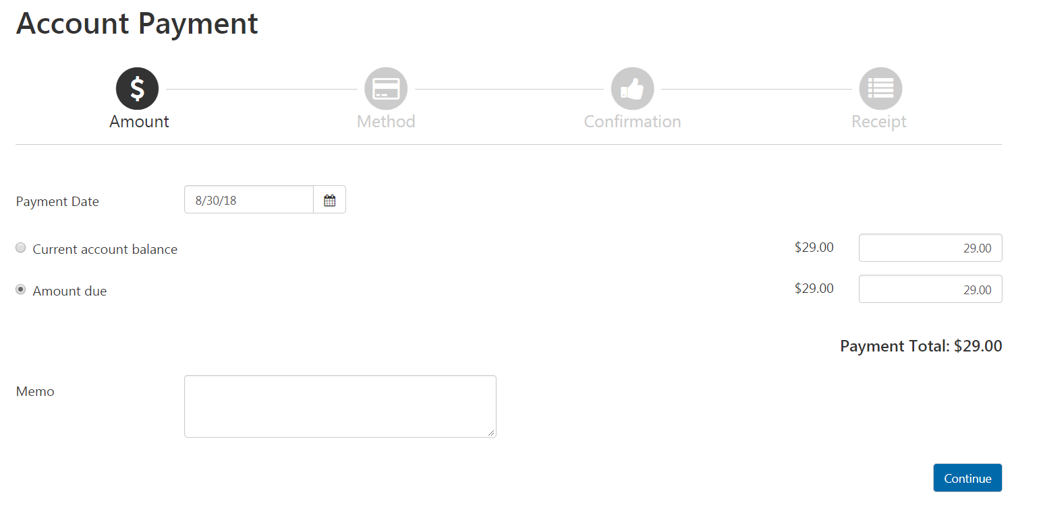
- Once you have entered the amount you would like to pay click continue:

- Once you have selected the amount and date please select the bank wire payment method and click continue:
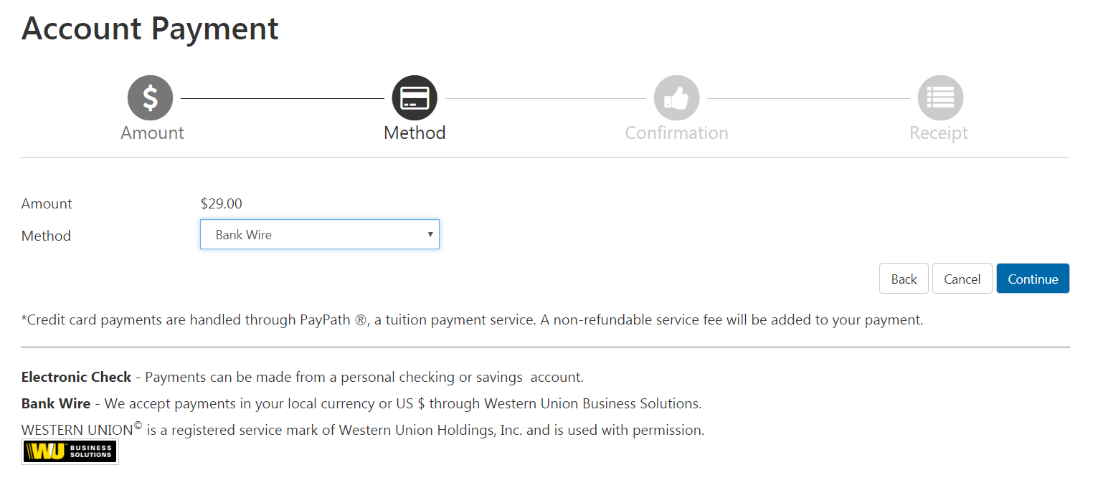
- Next enter the country from which your transaction will originate:
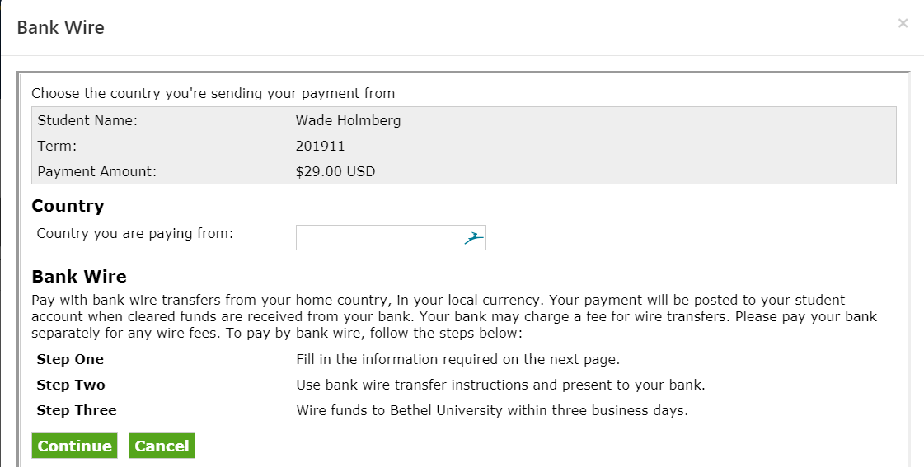

- Next enter all the required information including the email to which you would like payment instructions sent and then select continue:
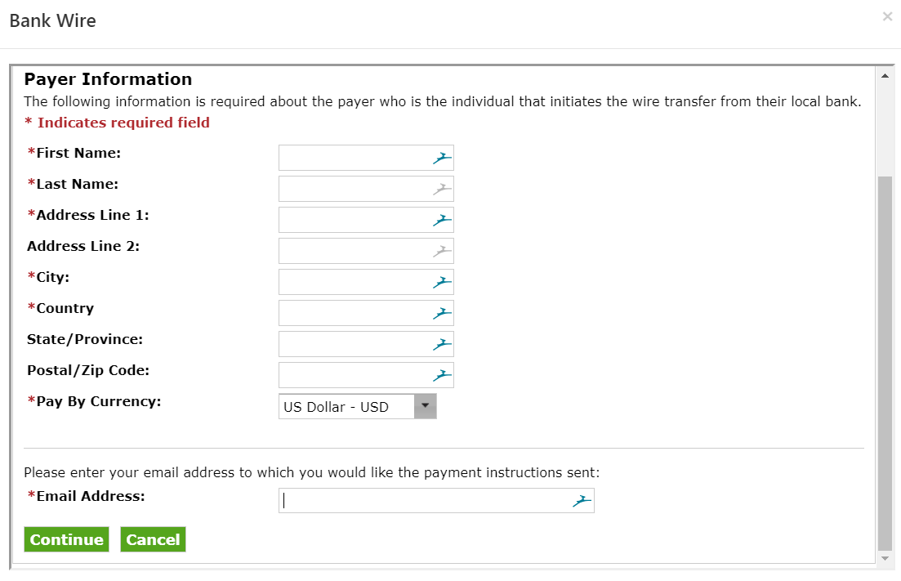
- Next review the amounts (please note the wire must be sent from your bank within 3 days) and click accept:
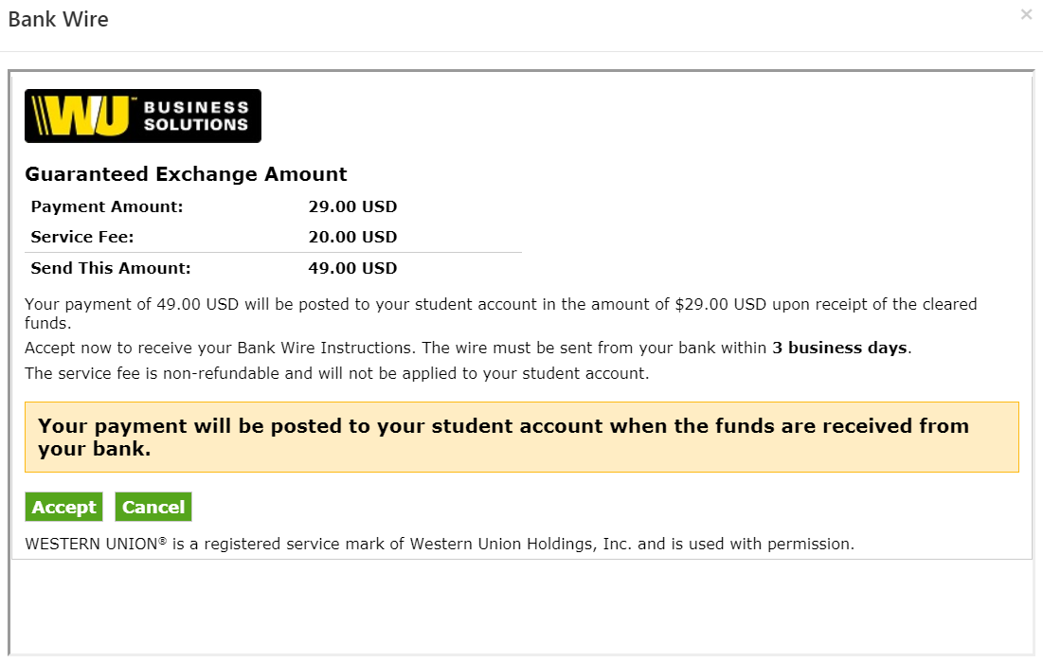
- One-time use instructions will be generated based on the country and currency you selected.
- Instructions will be sent to the email address you supplied.
- You have 72 hours form the time you accept the wire to take the one-time payment instructions to your bank to initiate a wire to maintain the locked-in exchange rate. After 72 hours, the one-time payment instructions will expire, and you will be required to go through the payment process again.
- You must ensure that the payment reference is included in the wire transfer details, or the payment will be delayed in posting to your student account.

Sample Payment instructions:

