RedShelf Products Tutorial

Ebook:
- Digital book ONLY
- On RedShelf’s platform
- Will access through Moodle
- For access issues, please reach out to RedShelf: https://solve.redshelf.com/hc/en-us/requests/new
Courseware (coded and codeless)
- Ebook AND homework, quizzes, etc
- On Publisher’s platform
- Students will ONLY access the opt-out button and codes through Moodle
- For access issues, please reach out to the Publisher, but feel free to loop me in!

Ebook:
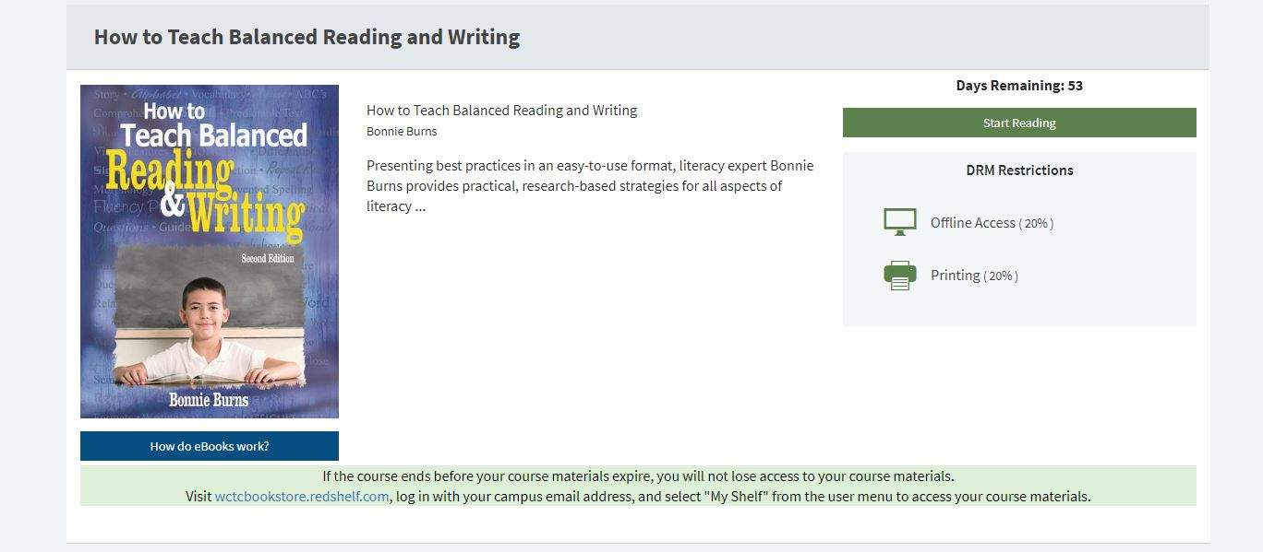

Coded Courseware:
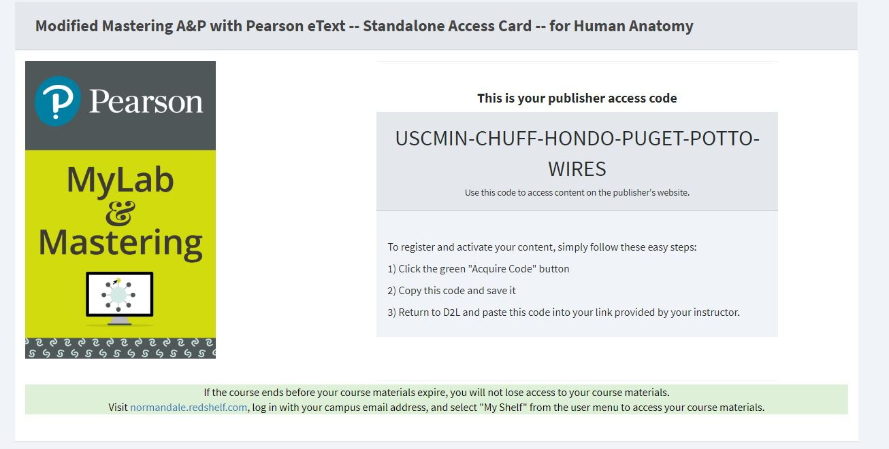

Codeless Courseware:
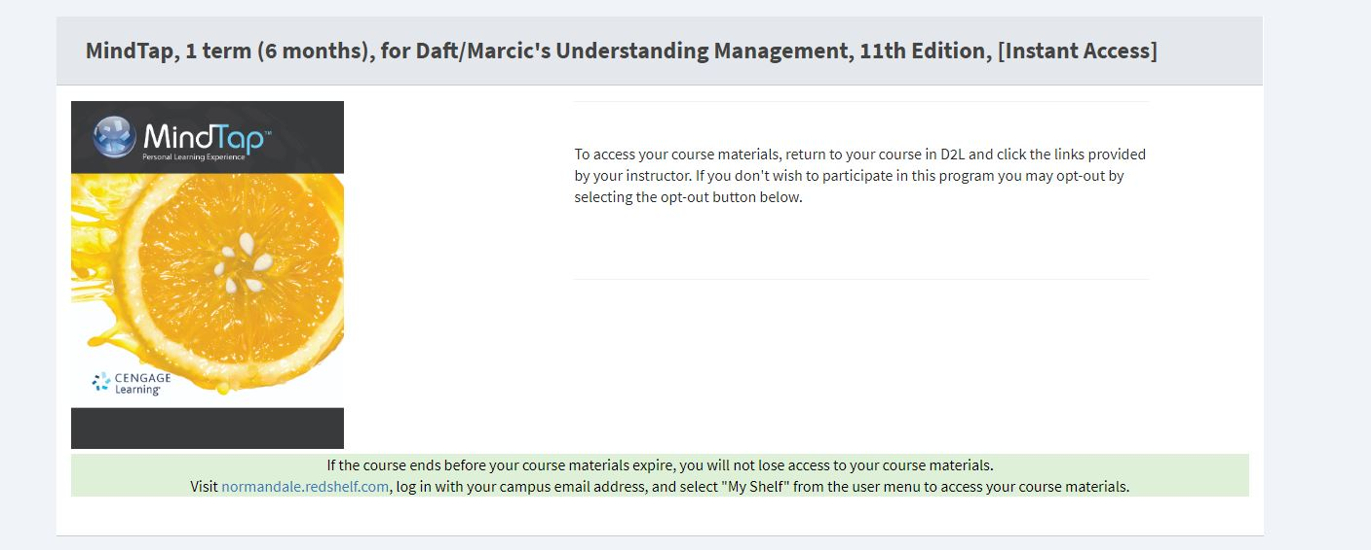

Troubleshooting Help with Instructor Outreach:
1. Please check if they have added the RedShelf Tool successfully: https://solve.redshelf.com/hc/en-us/articles/360048498113-Instructor-Steps-for-Adding-the-RedShelf-LTI-Tool-in-Moodle
2. For courseware, please check if they have been in touch with their Publisher rep and they have received everything they need to set up their course materials
3. If it is a student access issue, please check with the instructor that their student is accessing through Moodle. If they are, please ask the student to provide a screen shot of what they are seeing on their end
4. If the rosters do not match with what you see in the IA Dashboard on your end, please loop me and your LMS Team in an email to ensure we have the correct ID
Helpful Links from RedShelf Solve:
1. FAQ on all things Inclusive Access: https://solve.redshelf.com/hc/en-us/articles/360011565733-What-is-Inclusive-Access-
2. “Where Do I Direct My Students For Help?”: https://solve.redshelf.com/hc/en-us/articles/360015136774-Where-Do-I-Direct-My-Students-For-Help-
3. “Where do I submit a help ticket with RedShelf?”: https://solve.redshelf.com/hc/en-us/requests/new

