Information Technology Services/system services
Self-Service Banner User Guide
SSB Requisitions and Approvals

Initial Steps
- Connect to SSB via Blink’s Technology tab or use the following URL:
https://banner.bethel.edu/prod8/twbkwbis.P_WWWLogin
- Logon.
- Click on the ‘Finance’ tab.
- Click on ‘Requisition’ from the menu.
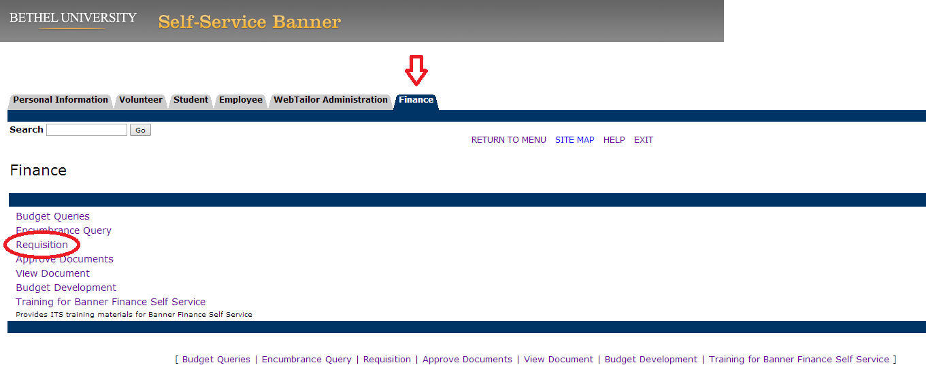

Requisition

Header Section
- Transaction date: This field will default to the current date.
- Delivery date: This field will default to the current date. You can keep the current date or select a date that is later than the transaction date.
- Vendor ID: Enter the Vendor ID and click on ‘Validate’.
- If the vendor id is correct, the vendor name and address will appear on the form. If you need to look up the id, then scroll to the bottom of the form and use the ‘Code Lookup’ function.
- Address type: This will default to ‘BU’. If address type defaults to ‘BI’, please contact the Purchasing Office.
- Address sequence: This will default to the most recent address on file. If the address currently being displayed is not correct, then change the sequence number and click on ‘Vendor Validate’ again. If another address is on file, it will display.
- Vendor Contact and E-mail: optional fields.
- Requestor name: This will automatically populate from the user profile. Any of this information can be overwritten if needed.
- Chart of accounts: This will default to ‘1’.
- Organization: This will default to user’s current department.
- Ship code: This will default to ‘B1’ for Bethel University. This can be changed if required.
- Comments: This field is for brief requisition comments. It can be used to designate purchase order disposition. This field will not print on the PO. Bethel University’s standard comments are:
(1) NEW VENDOR
(2) UPDATE VENDOR EMAIL
(3) NEW STANDING PO
(4) MULTIPLE REQS 1 OF 2
(5) COMMODITY LEVEL ACCOUNTING
Purchasing will know to look at the ‘Document text’ or ‘Item text' for further information when using these comments.

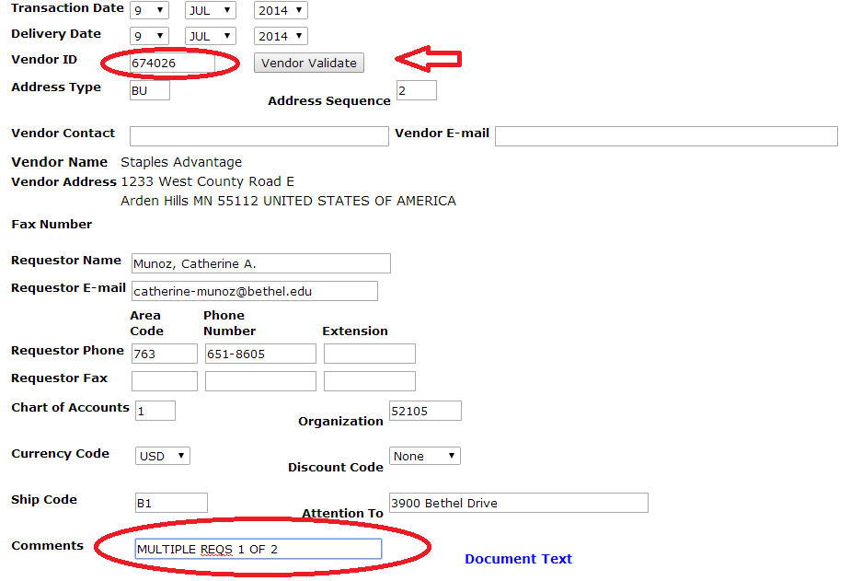

- Document Text: This field is for brief requisition comments. Text boxes will appear when you click on this link. These boxes are used for either notes to the vendor or purchasing staff. If the vendor is not in the system, enter the vendor information into the bottom box. The disposition of the order should be entered in the Document Text top ‘print’ box. Below are some examples:
(1) ALREADY ORDERED, NO ACTION NEEDED
(2) EMAIL TO: email_address
(3) FAX TO ATTN: name
(4) RUSH ORDER PO# P0020177
- IMPORTANT: Remember to click ‘Save’ after entering your text. If you exit without saving you will lose all your text.

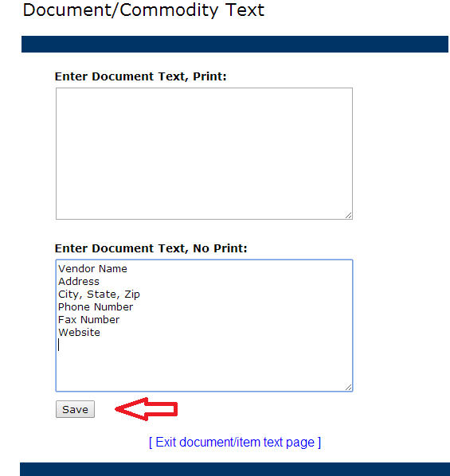

Document Text – Linking Multiple Requisitions
- If you have more than 5 commodities for you requisition, you will have to create multiple requisitions. You can note the linkage in the ‘Document Text, No Print:’ boxes in each requisition.

1st Requisition

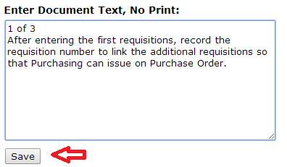

2st Requisition

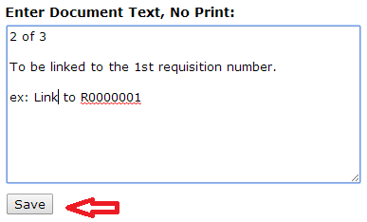

3st Requisition
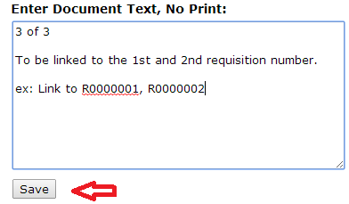

Commodity Section
- Commodity Description: Enter the description of the item you are requisitioning.
- Unit of Measure (U/M): Use the drop-down list and select the appropriate U/M.
- Quantity: Enter the number of items being ordered.
- Unit Price: Enter dollar amount of item. (no need for $ sign)
- Click on ‘Commodity Validate’.
- The calculated commodity amounts will appear in the box below.
- Item Commodity Code, Discount Amount and Additional Amount columns are not used.

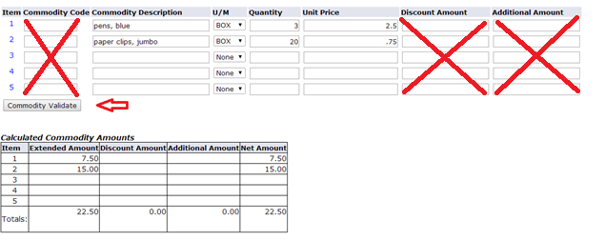

Commodity Section – Item Text (use for Standing POs)
- If the commodity requires more detail, it can be added by the ‘Item Text’ link. This is indicated by the blue number to the left of the commodity description.
- Click on the blue item number to open the commodity text box.
- Enter the additional information for the item.
- The commodity text format for Standing POs is: department name, Standing PO, description and dates.
- IMPORTANT: Remember to click ‘Save’ after entering your text. If you exit without saving you will lose all your text.

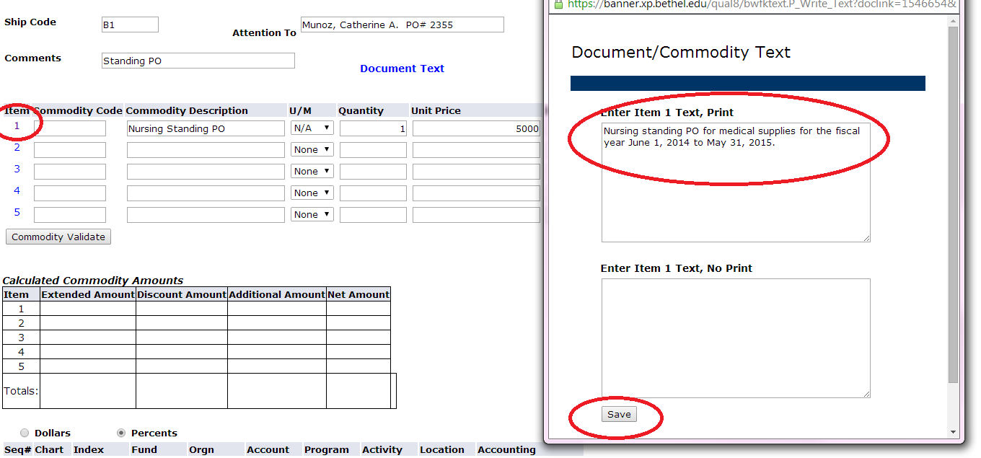

FOAPAL Accounting Information
- Dollars/Percent buttons: Automatically defaults to’ Percents’. Change to Dollars.
- Chart: The Chart should always be set to ‘1’.
- Index: This field is not used.
- Fund: Enter the fund for the requisition. Most requisitions will use the general fund (110000 – Bethel’s general operating fund). The fund code is associated with the fund from which the purchase of the commodities will be financed.
- Orgn: Enter the code associated with the organizational budget against which the purchase of the commodities will be charged. This code is tied to the department.
- Account: Enter the account that best describes the category of expense. (ie 7001 - Supplies and Expense)
- Program: Enter the program code associated with the Orgn number you utilized. The program code identifies a function (ie. 50 - Student Services, 60 - Institutional Support)
- Accounting: Enter the total amount of the requisition. This is a REQUIRED field; an error message will appear if this field is not entered. This amount needs to equal the ‘Net Amount’ in the Commodity section.
- Activity and Location: Optional fields. These columns are rarely used.
- Click ‘Validate’. A validation or error message(s) will appear at the top of the screen.

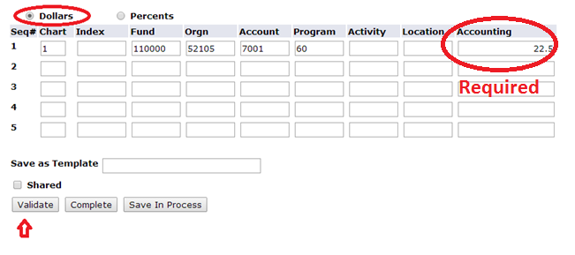

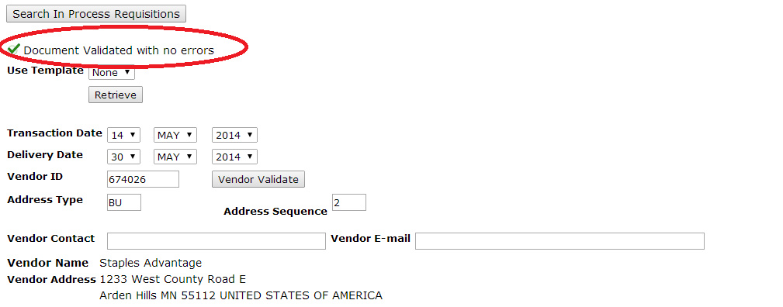

- After validating the requisition, you can either ‘Complete’ or ‘Save In Process’. A completed requisition will be sent through the approval process and Purchasing will create a purchase order. A completed requisition cannot be edited. If the requisition is not complete, click on ‘Save In Process’. A saved requisition can be modified later and then ‘completed’.

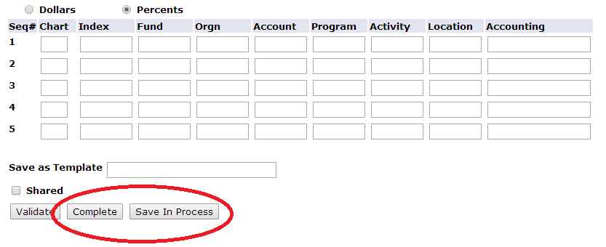

Save as Template and Complete Section
- Optional. If you frequently complete requisitions that are similar, (same vendor, commodities, accounting) you can save the requisition you just completed as a template by entering a name here. You will then be able to retrieve the template and save time entering data. If you check shared, the template will be available for all to use. Naming conventions – all templates should be prefixed with a three to four character department code along with a brief description. Examples of department codes are: ITS, BIO, MUS, CHEM, NURS, BUS, EDUC. This will make it easier for each department to identify their templates.

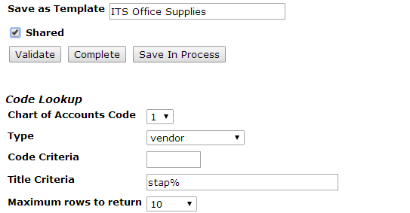

- Complete the requisition by clicking on the ‘Complete’ button.
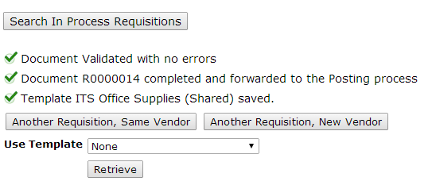

Code Lookup Section
- Type: Select the type from the drop down box.
- Title: Type in the name or partial name followed by a wildcard ‘%’.
- Max rows to return: You can change the number of matching results.
- Execute query: Click on this button to see the list that matches your search criteria. The list of values will appear at the top of the screen.

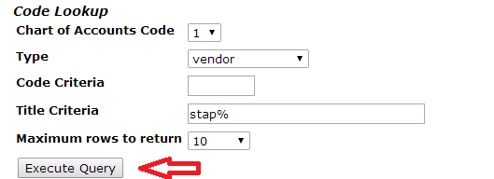

- In this example ‘Vendor’ was the type that was searched. Find the required vendor ID and enter the number in the ‘Vendor ID’ field.

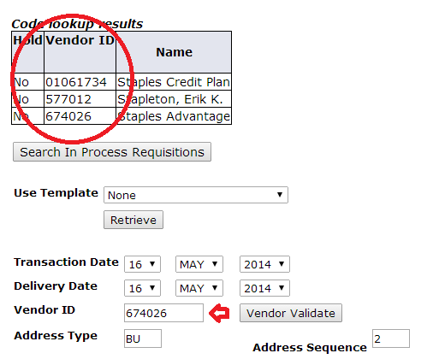

Validate Error Messages Lookup Section

- If the requisition is missing information you will receive an error message(s) at the top of the requisition. You must fix all error messages before the requisition can be completed.

Error Message | Solution
Ship code is required | Enter the Ship Code in the header of your requisition (i.e. B1 for 3900 Bethel Drive).
Commodity 1 is required | Enter the Commodity description for line 1.
Organization is required in the header section | Enter your Organization in the header section of your requisition.
Quantity 1 is required | Enter the Quantity for line 1.
Accounting amounts not equal to net amount total | Enter the dollar amount distribution in the Accounting column for the requisition. Located after the Calculated Commodity Amounts table.
Chart of sequence 1 is required | Enter the Chart number. This is always set to ‘1’.
No permission to use fund XXX | Contact Purchasing to obtain fund access.
No permission to use org XXX | Contact Purchasing to obtain organization access.
There is no default address for this Vendor | Contact Purchasing to update the procurement address code.

View Document

Initial Steps
- Click on ‘View Document’ from the Finance menu.
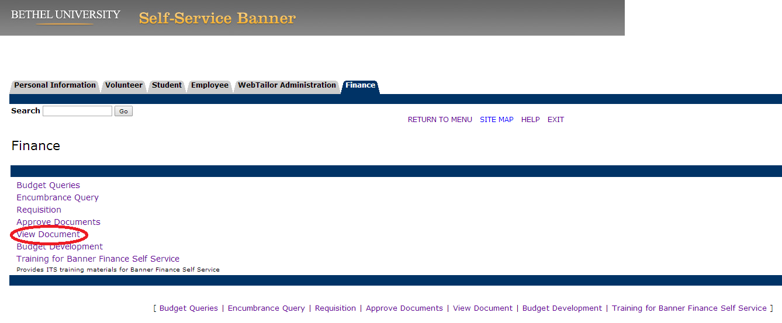

View Document with Requisition Number
- Document Number: enter the document number.
- Click on ‘View document’.
- To view the entire requisition, use the defaults for the radio buttons.

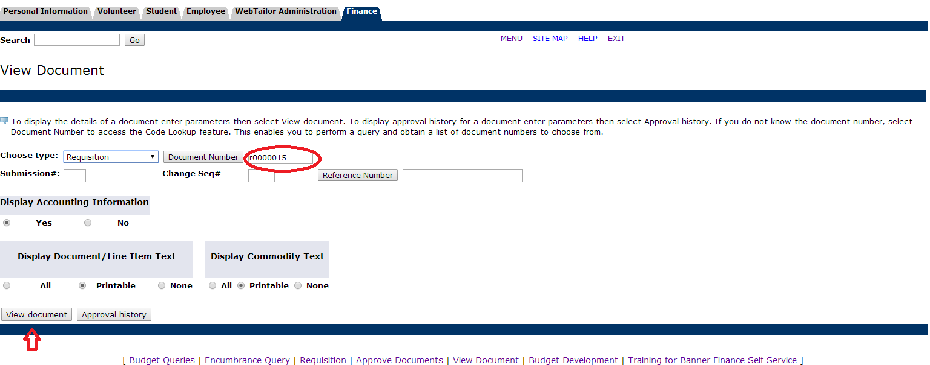

- The requisition will display on the screen in its entire format.
- If a purchase order has been assigned to the requisition, it will display at the bottom in the ‘Related Documents’ section. You can click on the purchase order to view the PO.
- All purchasing documents will remain in Banner and can be viewed at any time. No documents are every purged from the system.

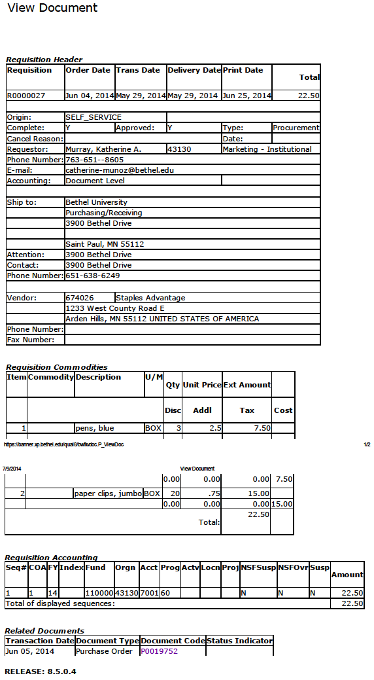

View Purchase Order from Requisition view
- If a purchase order is listed in the ‘Related Documents’ section, click on the PO number.
- The entire PO will display on the screen.
- In the example below, three requisitions where used to create this one PO.

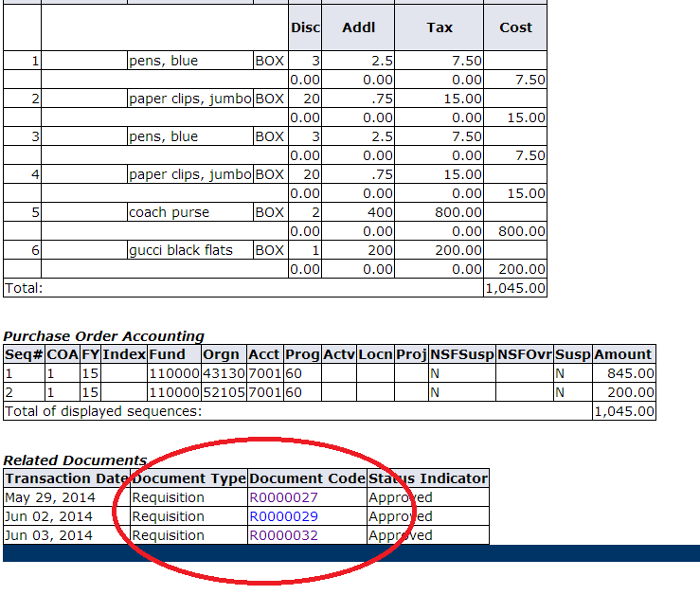

View Document With Out Requisition Number
- Click on the ‘Document Number’ tab to go to the ‘Document Lookup’ screen.

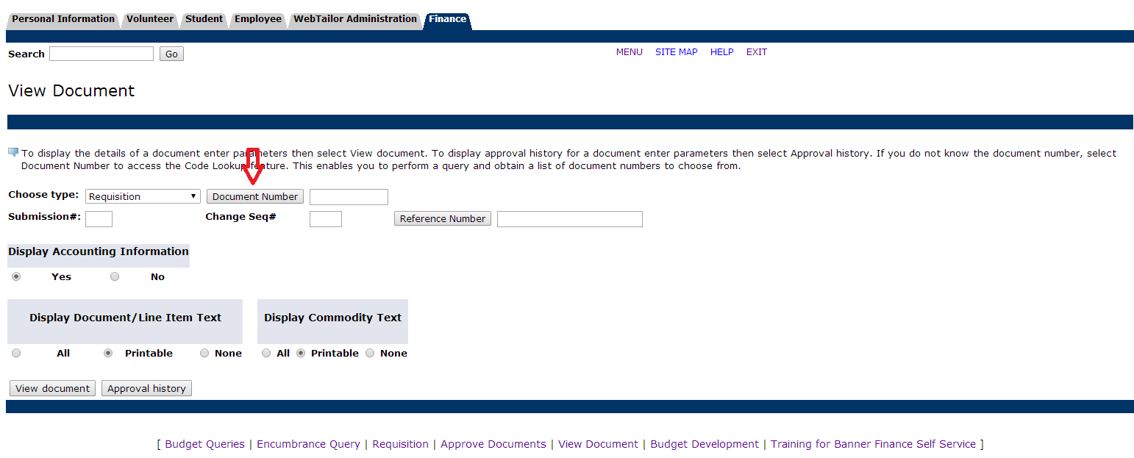

- Either use the ‘User ID’ default settings or enter the selection criteria required.
- Click on ‘Execute Query’.

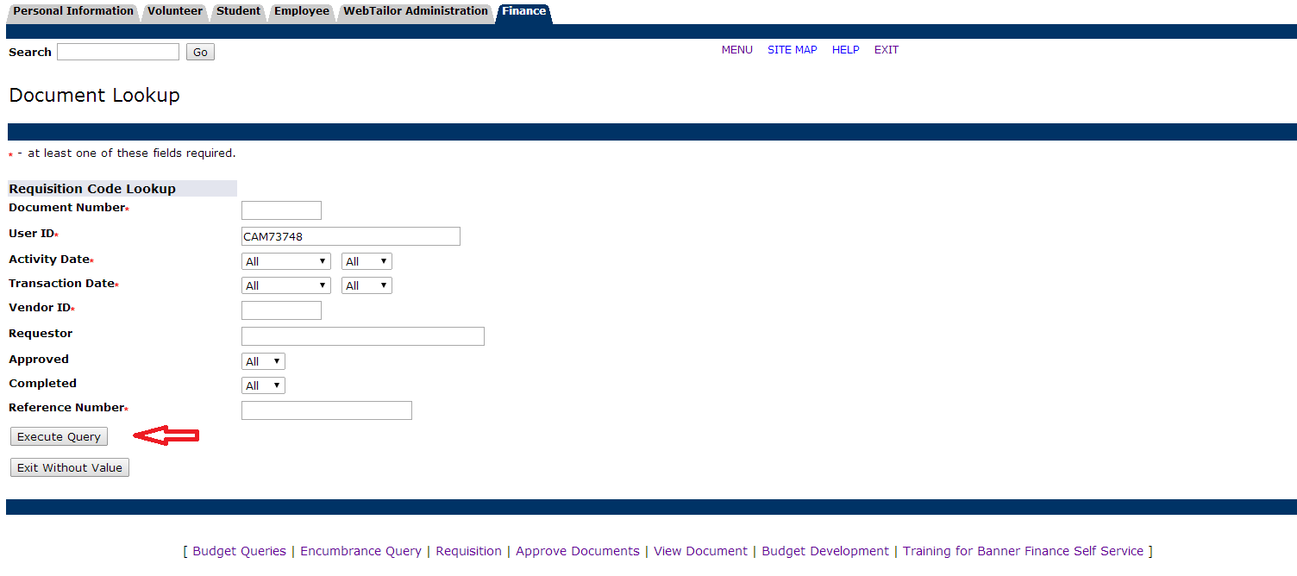

- Choose the document link to view the document page.
- This page will also show you all of your requisitions. In this example, the first two are completed and have been approved. The last two were ‘Saved in Process’ and still need to be completed, before an approval can occur.

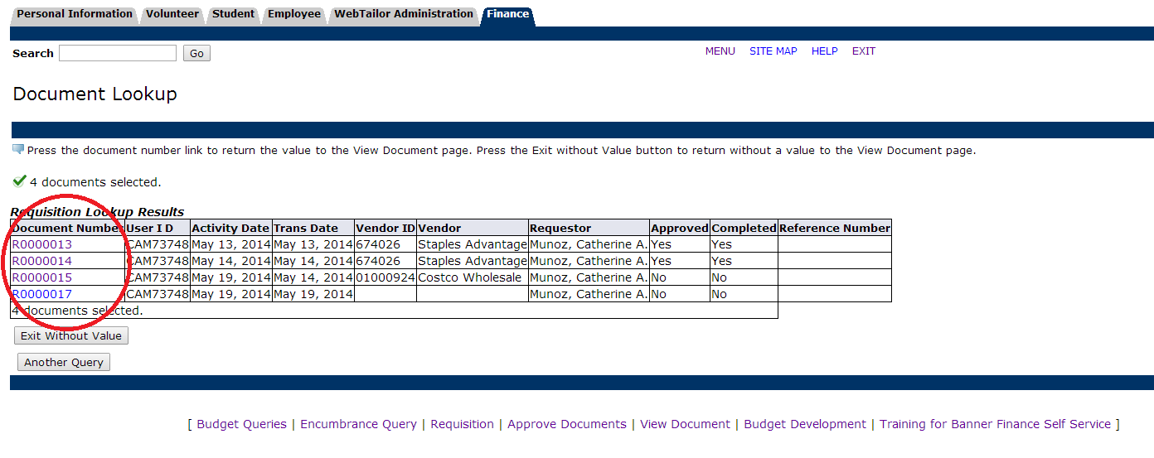

View Document Approval History
- Document Number: enter the document number.
- Click on ‘Approval history’.
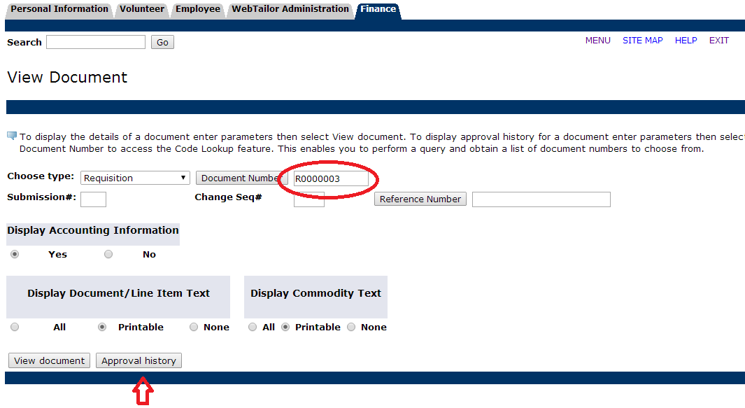

- Both approvals required and record will display for the entered requisition.
- If a requisition is not approved, an email will be sent to the end-user along with a reason for the disapproval.

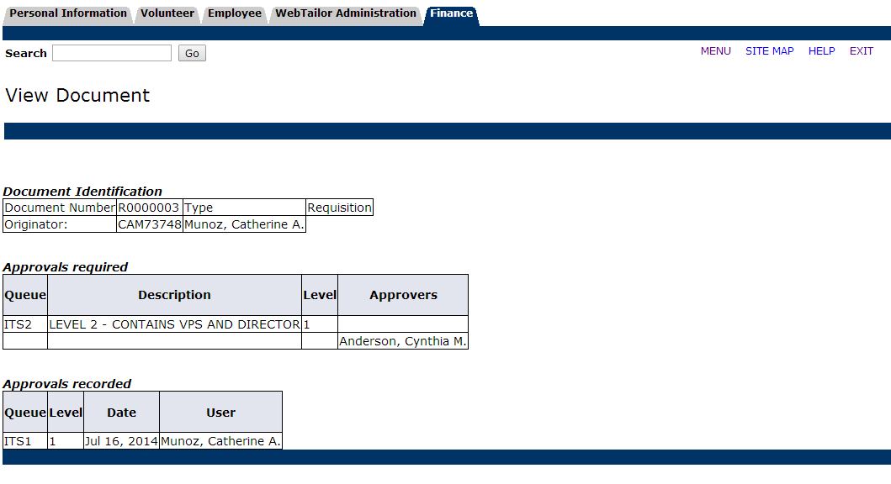

View ‘In Process’ or Disapproved Requisitions
- Select ‘Requisition’ from the Finance Menu.
- Click on ‘Search In Process Requisitions’ to access the ‘Document Lookup’ screen.

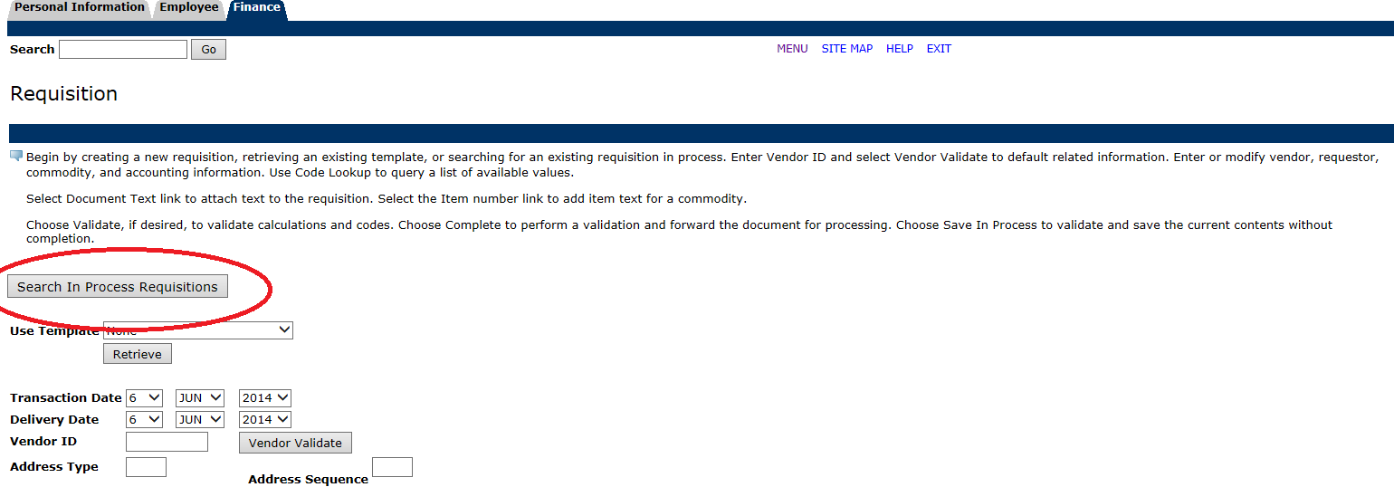

- Click on ‘Execute Query’

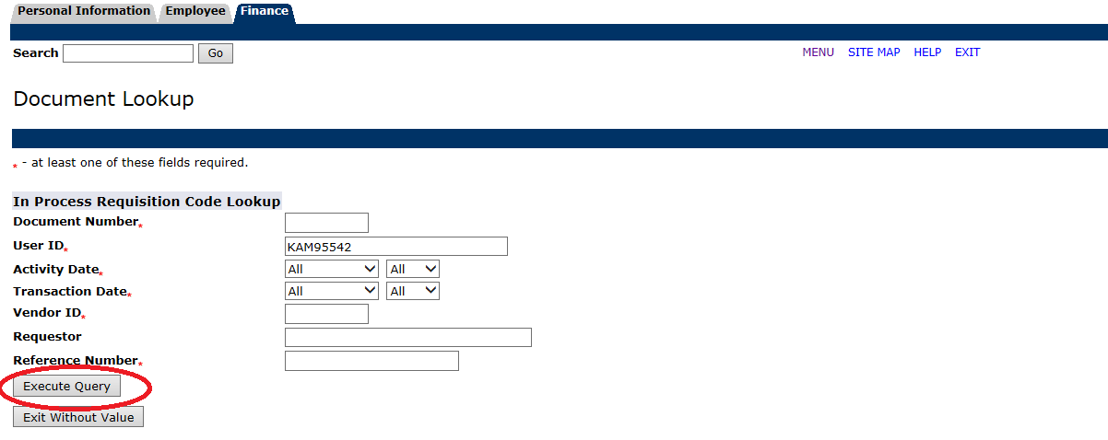

- In this example, two requisitions are listed. The first one was completed, but disapproved. Disapproval notices will be emailed to the end-user. To correct the requisition, click on the document number, edit, and ‘Complete’. The second document was ‘Saved in Process’ and needs to be edited and completed.

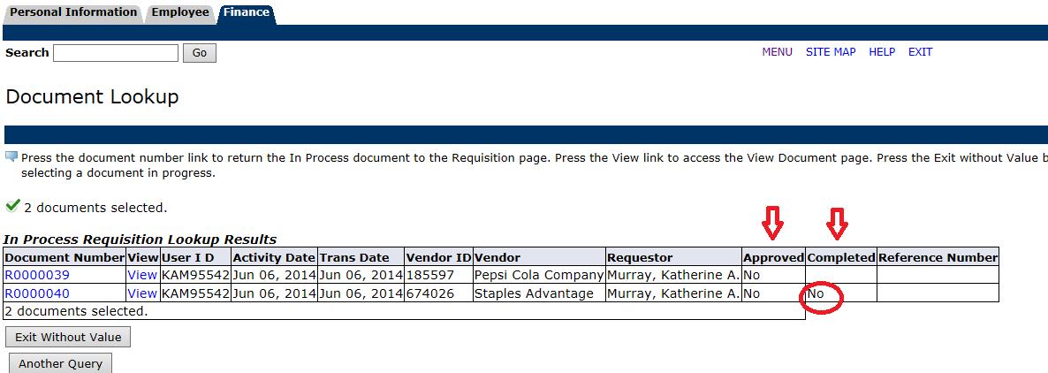

Approve Documents

Initial Steps for Approving Requisitions
- From the Finance menu click on ‘Approve Documents’.
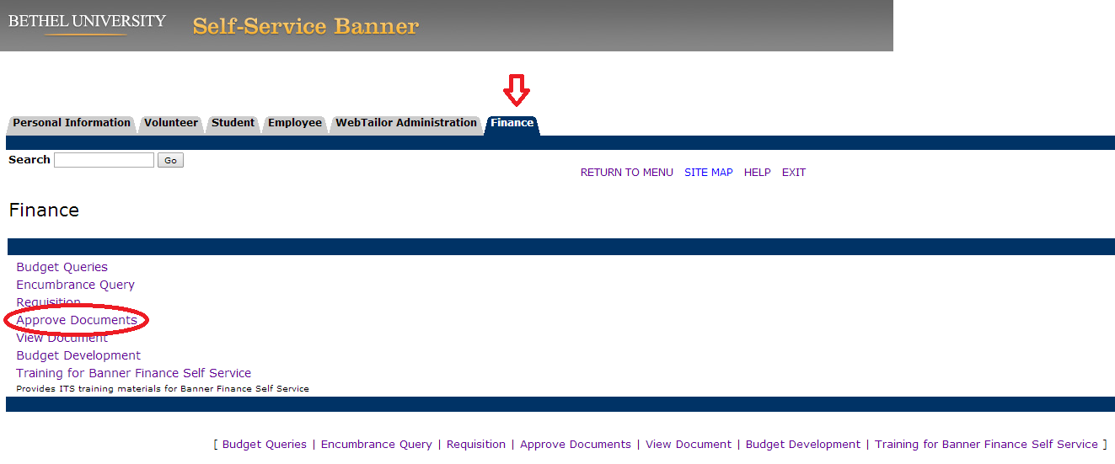

Enter Approval Parameters Section
- User ID: This will default to your user id from the logon.
- Document Number: If you know the requisition number, enter it here and click on ‘Submit Query’. To see all requisitions needing approval, leave the ‘Document Number’ field blank and ‘Submit Query’.

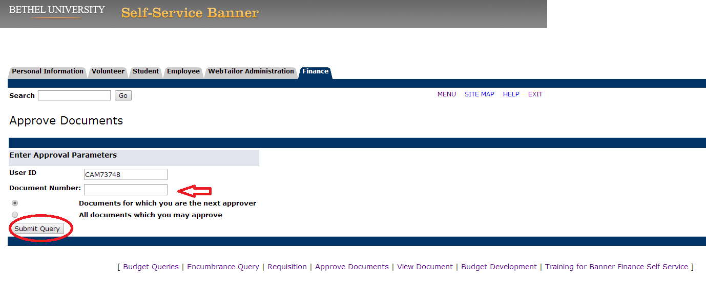

Approve/Disapprove Requisition Overview
- There are four options on this screen.
- (1) Click on the document number to view the requisitions.
- (2) Click on ‘History’ to view approvals required and the approvals recorded.
- (3) Click on ‘Approve’ to approve the requisition.
- (4) Click on ‘Disapprove’ to disapprove the requisition.

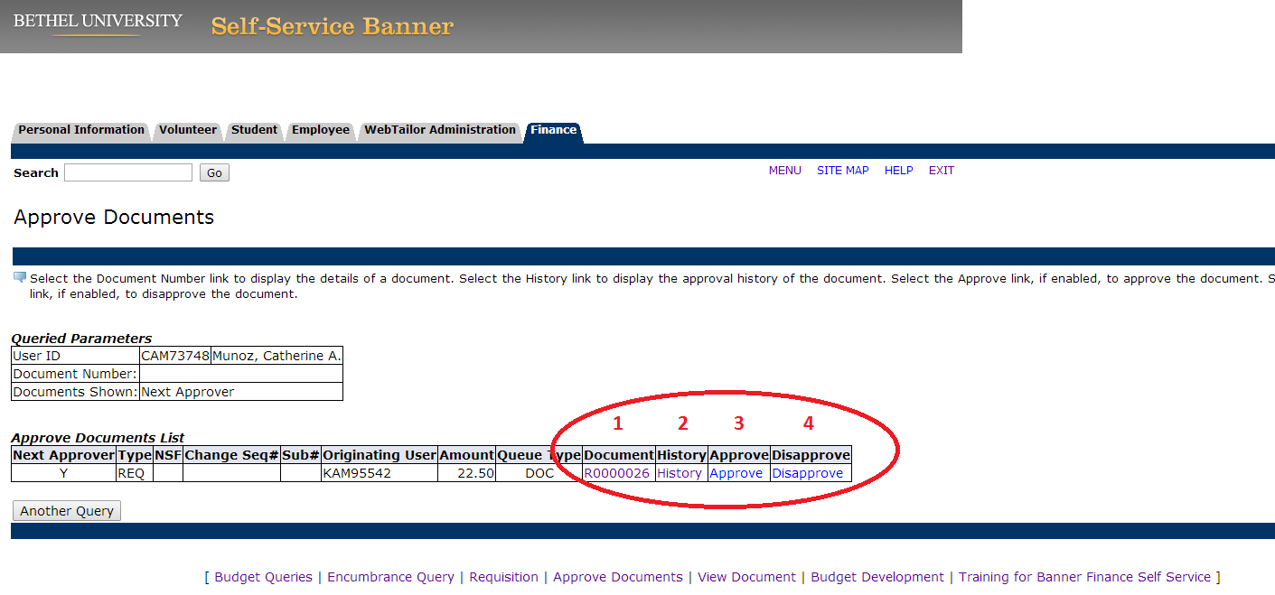

Approve/Disapprove Requisition
- To approve a requisition, click on the ‘Approve’ link and then the ‘Approve Document’ button.
- To disapprove a requisition, click on the ‘Disapprove’ link and add to the comment box a reason for the disapproval. Click on the ‘Disapprove Document’ button.

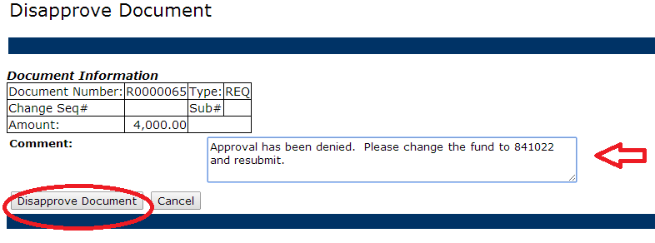

- The following display will show and reflect the disapproval.
- The requisition is now ‘in process’ and can be edited and ‘Completed’ via SSB.
- If the requisition has been disapproved, an email will be sent containing the ‘Comment’ message to the end-user. The requisition can be retrieved and corrected via the ‘Requisition’ menu using the ‘Search in Process Requisition’. After correction, ‘Complete’ the requisition. It will then run through the approval process again.

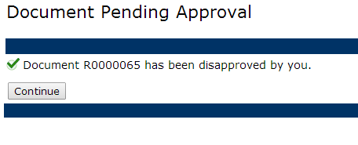

Request for Payment
A Request For Payment (RFP) is used to pay a vendor in circumstances where no invoice is provided. Bethel University’s directive is to minimize the use of RFPs. RFPs are allowed for:

- Memberships
- Subscriptions
- Honorariums
- Travel
- Consulting
- Conferences
- Dues
- Out of pocket expenses
- Mileage
- Entry fees
- Reimbursements
- Referees – Athletics
- Official fees – Athletics

Requisition
The Purchase Requisition is only for internal use within Bethel University and is the first step in the process of generating a Purchase Order. It is a method of ensuring that supplies and spending are carefully controlled. The Requisition is a formal way of issuing notice that material is required. Requisitions have to be authorized, so there is a clear indication of who wanted the items and who said that it could be purchased. This is important in terms of being an audit trail. Requisitions should be used for:

- Equipment
- Supplies and products
- Apparel
- Buses
- Contracts with bids, quotes, or work orders
- Licenses
- Maintenance
- Rentals
- Re-occurring expenses

