How to Read the Transfer Evaluation System (TES)
To find a course from a different school | To find a Bethel general education requirement | To find a Bethel major or minor requirement
- Find the name of the transfer school/university  - Click on school name or “SEARCH” in that row  - Type the other school’s course code into the box  - Select “SEARCH”  - Click on to add the desired course to “my list”  - Add additional courses  - Print or email “my list” | - Find the name of the transfer school/university  - Click on “GUIDES” in the row of the transfer school  - Select the > next to the desired general education category  - Click on “VIEW”  - Click on to add the desired course to “my list”  - Print or email “my list” | - Find the name of the transfer school/university  - Click on school name or “SEARCH” in that row  - Type the Bethel course number into the box  - Click the button next to “home course”  - Select “SEARCH”  - Click on to add the desired course to “my list”  - Print or email “my list”

Trouble Finding the Course:
- If the course is not listed, the course has not been evaluated by our faculty yet. Please fill out the online petition form: https://www.bethel.edu/undergrad/admissions/explore/undergrad-course-petition
- If the school is not listed, you can fill out the above petition form or e-mail a copy of your unofficial transcript to cas-registrar@bethel.edu
Understanding Transfer Equivalencies:
- If a credit range is listed or there is a credit discrepancy between the transfer course and the equivalent Bethel course, the course will always transfer in as the same number of credits for which it was taken.
- Each row is one equivalency:
one course will transfer in as two courses
two courses are required to be equivalent to one Bethel course
two transfer courses will transfer in as two Bethel courses | 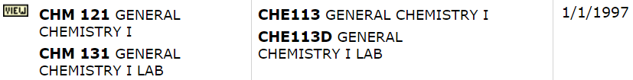
this course can transfer in as one or the other Bethel equivalency, not both | 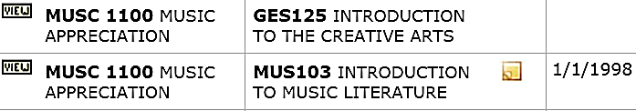

End Dates on Transfer Equivalencies:
Bethel Course Number Changes:  (only the current Bethel course equivalency will show in the default view) | 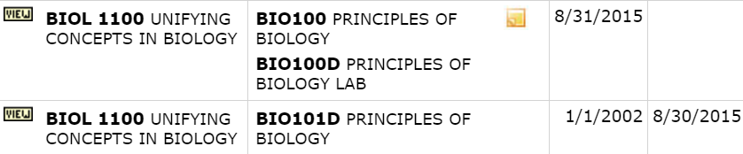
Change in Bethel’s Gen Ed Curriculum:  Students starting at Bethel before Fall 2017  Students starting at Bethel in Fall 2017 or after | 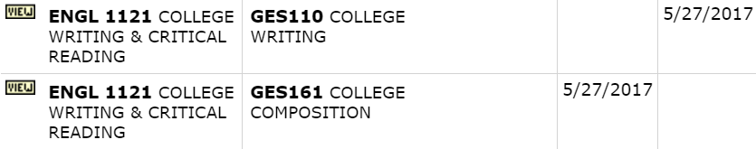
Change in Bethel’s Gen Ed Curriculum:  Students starting at Bethel before Fall 2017  Students starting at Bethel in Fall 2017 or after | 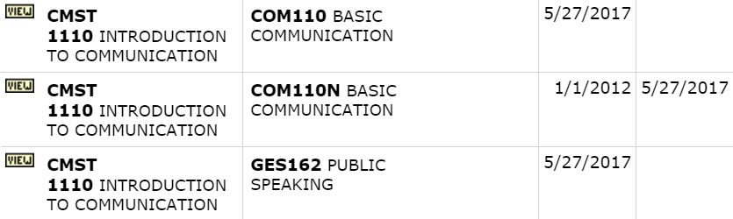
Change in Bethel’s Gen Ed Curriculum:  Students starting at Bethel in Fall 2019 or after  Students starting at Bethel before Fall 2019 | 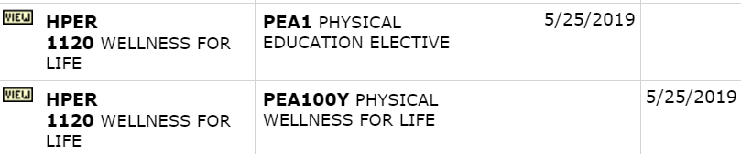
Change in Bethel’s Gen Ed Curriculum:  Students starting at Bethel in Fall 2019 or after  Students starting at Bethel before Fall 2019 | 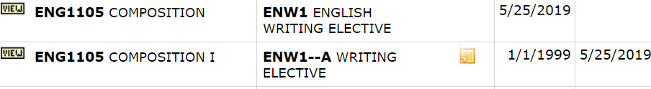

If you are looking for a Bethel course that is no longer offered:
- Find the name of the transfer school/university
- Click on school name or “SEARCH” in that row
- Select “SHOW ALL SEARCH OPTIONS”
- Change “Effective Date” option to “SHOW ALL”
- Type the Bethel course number into the box
- Click the button next to “home course”
- Select “SEARCH”
For more information:
- Go to: https://www.bethel.edu/registrar/transfer-credits/transfer-evaluation-system
- E-mail: cas-registrar@bethel.edu

